**Play that track, ross!  
A rube goldberg machine**

By  
*Charlie Nitschelm, Ross Thyne  
 Lucas Simmonds and Victor Leandro*

Group Number: 25

ME 627 Final Project Report

University of New Hampshire

Department of Mechanical Engineering

Durham, *2018*

Table of Contents

List of Figures ii

List of Tables ii

Introduction and Background 1

Description of the Device 1

Description of Motion 2

Numerical Analysis 3

Observations 3

Comparison of Predicted and Observed Data 3

Summary and Conclusion 3

References 4

# List of Figures

Figure 1 - 2D representation of the rube goldberg device with measurements recorded priot to test 1

# List of Tables

Table 1 - Play That Track, Ross! processes explained with the types of energy and energy transfer observed 2

# Introduction and Background

A Rube Goldberg device exemplifies the harmony between the dynamic motion of objects. A simple cut of a string can cause huge implications if the device is designed to easily transfer potential into kinetic energy. People around the world have created systems that can be reset over and over to make a certain task easier to do every day. It also can lead a creative, student team to over complicate a simple task of turning on a record player. Voyager One, the first of two spacecraft to leave the solar system, brought with it a piece of human history unlike anything ever made before. A record consisting of the history, sounds and pictures of Earth was on board, wandering the universe to one day be picked up by lifeforms unknown to us. With the work of almost every country on Earth, our pale, blue dot collaborated together to bring forward the best of ourselves to maybe, one day, communicate with whoever else might be out there. We recently got our hands on this record, and was inspired to create a device that would turn it on with a simple light of a match.

# Description of the Device

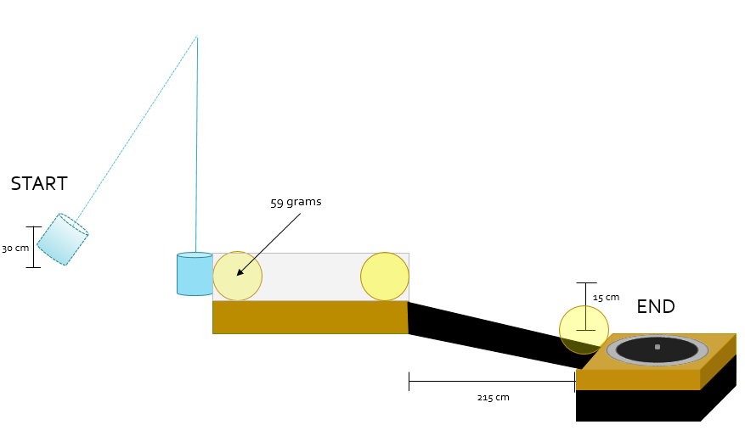

Figure 1 - 2D representation of the rube goldberg device with measurements recorded priot to test

The figure above illustrates our device and its basic function. The measurements added to the figure details the measurements taken prior to our test to help us fully analyze the motion once the tes tis complete. Several materials need to be obtained for this device to be functional. All of our materials were found in the UNH SEDS shop in Kingsbury Hall S172 and the machine shop in S172. The materials that brought this experiment to life were:

* Hanging electrical cord
* Lighter
* Tennis ball
* String
* Plexiglass plates
* Tape
* Piece of wood
* Scrap ramp
* Paper
* Record player
* Voyager track

# Description of Motion

Although it might be easier to manually turn the record player on by hitting a switch like most people, but being engineers, we wanted to think of a more complicated way to do the same thing. Our device takes the act of flipping on a record player to a more extreme level, requiring pendulum motion, rigid body collisions, and rolling dynamics along a striaghtaway with imparting force and a ramp. The following table details each process of the machine, explaining the types of motion and energy transferred from process to process.

Table 1 - Play That Track, Ross! processes explained with the types of energy and energy transfer observed

|  |  |  |  |  |
| --- | --- | --- | --- | --- |
| **Step** | **Type of Motion** | **Initial Energy** | **Energy Transfer** | **Final Energy** |
| **1** | Pendulum | Potential | Gravity | Kinetic |
| **2** | Collision | Kinetic | In-Elastic Collision | Kinetic |
| **3** | Flat Path | Kinetic | Impulse from Wall | Potential/Kinetic |
| **4** | Ramp | Potential/Kinetic | Gravity | Kinetic |

The table gives a clear representation that the intitial energy of the system is from the pendulum, starting at a height large enough to impart an impulse to a tennis ball, waiting for the second Step to occur, collision. Once the collision is over, the tennis ball has a momentum that carries it through the constrained path that is constantly imparting an impulse as it bounces around the walls. Once it reaches the end of the path, or the end of Step 3, it begins Step 4 that uses potential energy to continues its momentum direction toward the switch of the record, where it then collides with the switch, turning the record player on. By not assuming an elastic collision, a coefficient of restitution must be found to understand the amount of energy loss was experienced during the collision. With that and the speed of the ball at the end of the machine, a simple “work backwards” technique can be used to calculate the total amount of impulse that the wall imparted on the ball during Step 3.

# Numerical Analysis

# Observations

# Comparison of Predicted and Observed Data

# Summary and Conclusion

# References

|  |  |
| --- | --- |
| [1] | P. J. Pritchard, Fox and McDonald’s Introduction to Fluid Mechanics, 8th edition, John Wiley & Sons, Inc., 2011. |
| [2] | S. F. Hoerner, Fluid-Dynamic Drag: practical information on aerodynamic drag and hydrodynamic resistance, Hoerner Fluid Dynamics, 1965. |
| [3] | R. E. Sheldahl and P. C. Klimas, "Aerodynamic Characteristics of Seven Symmetrical Airfoil Sections Through 180-Degree Angle of Attack for Use in Aerodynamics Analysis of Vertical Axis Wind Turbines. Report SAND80-2114.," Sandia National Laboratories, 1981. |